A Charter Member
Of the
Finger Lakes Library System

2026
Board of Trustees

Jaclyn Schnurr
President

Jessica Hess
Vice President

Kimberly Miller
Treasurer

Bonnie Thomas
Secretary

Marcia Clark

Geraldine Germano-Yaw

Rachel McNabb

The Powers Library Association is a
not-for-profit charitable organization.
Contributions are tax deductible under IRS regulations per
Section 501 (c)(3)

Esto Perpetua

POWERS LIBRARY ASSOCIATION
Community Needs Survey 2026

- Do you use the library?
  - Every week
  - Once a month
  - Infrequently
  - Never

- What could the library do to increase your usage?

- What types of educational programs would you be interested in seeing at the library? Indicate all that apply
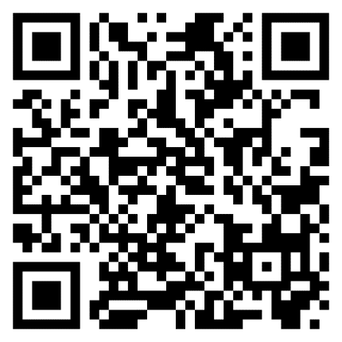
  - Health and wellness
  - History genealogy
  - Music
  - Arts
  - Business/finance
  - Technology
  - Crafts (knitting, gardening, etc)
  - Science and nature
  - Resume building
  - Anything else?

- How do you use the library?
  - Take out/read books
  - Computers and printers
  - eBooks and online resources
  - other

- What would you like to see the library add in the future?

- Is there something else you would like us to know?

- What should our top priorities be for the future?

- We would love your insight! We are looking for a slogan for the library! Which of these is your favorite, or do you have a better idea?
  - More than books
  - Read local!
  - Get in the know at the library
  - Building futures
  - Great communities have great libraries
  - You belong here
  - Where learning is fun
  - Come read with us
  - Your community hub
  - Rich in history, positioned for the future
  - Explore without limits
  - Connecting the past
  - _______________

Are you interested in serving as a library trustee? Pick up an application!

